EJERCICIO 1

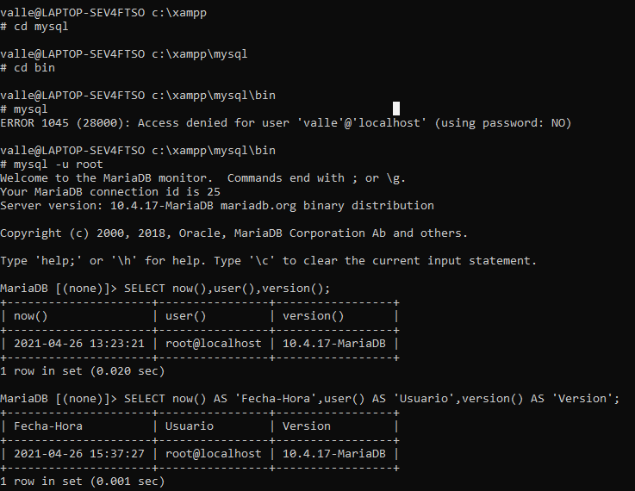

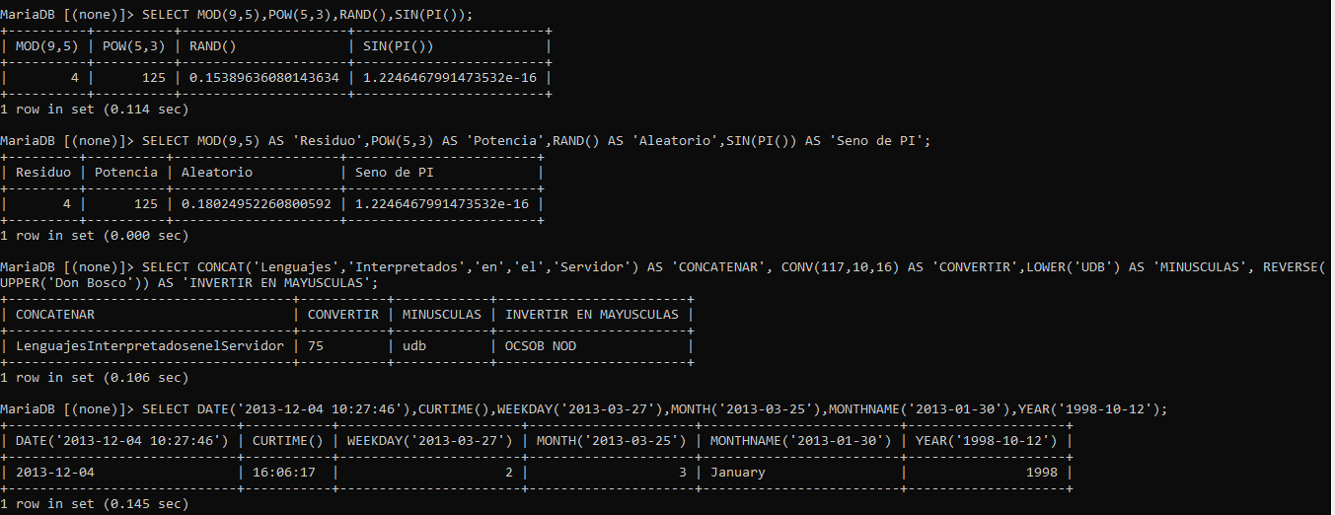

Setting environment for using XAMPP for Windows.

valle@LAPTOP-SEV4FTSO c:\xampp

valle@LAPTOP-SEV4FTSO c:\xampp

# cd mysql

valle@LAPTOP-SEV4FTSO c:\xampp\mysql

# cd bin

valle@LAPTOP-SEV4FTSO c:\xampp\mysql\bin

# mysql -u root

Welcome to the MariaDB monitor. Commands end with ; or \g.

Your MariaDB connection id is 25

Server version: 10.4.17-MariaDB mariadb.org binary distribution

Copyright (c) 2000, 2018, Oracle, MariaDB Corporation Ab and others.

Type 'help;' or '\h' for help. Type '\c' to clear the current input statement.

MariaDB [(none)]> SELECT now(),user(),version();

+---------------------+----------------+-----------------+

| now() | user() | version() |

+---------------------+----------------+-----------------+

| 2021-04-26 13:23:21 | root@localhost | 10.4.17-MariaDB |

+---------------------+----------------+-----------------+

1 row in set (0.020 sec)

MariaDB [(none)]> SELECT now() AS 'Fecha-Hora',user() AS 'Usuario',version() AS 'Version';

+---------------------+----------------+-----------------+

| Fecha-Hora | Usuario | Version |

+---------------------+----------------+-----------------+

| 2021-04-26 15:37:27 | root@localhost | 10.4.17-MariaDB |

+---------------------+----------------+-----------------+

1 row in set (0.001 sec)

MariaDB [(none)]> SELECT MOD(9,5),POW(5,3),RAND(),SIN(PI());

+----------+----------+---------------------+------------------------+

| MOD(9,5) | POW(5,3) | RAND() | SIN(PI()) |

+----------+----------+---------------------+------------------------+

| 4 | 125 | 0.15389636080143634 | 1.2246467991473532e-16 |

+----------+----------+---------------------+------------------------+

1 row in set (0.114 sec)

MariaDB [(none)]> SELECT MOD(9,5) AS 'Residuo',POW(5,3) AS 'Potencia',RAND() AS 'Aleatorio',SIN(PI()) AS 'Seno de PI';

+---------+----------+---------------------+------------------------+

| Residuo | Potencia | Aleatorio | Seno de PI |

+---------+----------+---------------------+------------------------+

| 4 | 125 | 0.18024952260800592 | 1.2246467991473532e-16 |

+---------+----------+---------------------+------------------------+

1 row in set (0.000 sec)

MariaDB [(none)]> SELECT CONCAT('Lenguajes','Interpretados','en','el','Servidor') AS 'CONCATENAR', CONV(117,10,16) AS 'CONVERTIR',LOWER('UDB') AS 'MINUSCULAS', REVERSE(UPPER('Don Bosco')) AS 'INVERTIR EN MAYUSCULAS';

+------------------------------------+-----------+------------+------------------------+

| CONCATENAR | CONVERTIR | MINUSCULAS | INVERTIR EN MAYUSCULAS |

+------------------------------------+-----------+------------+------------------------+

| LenguajesInterpretadosenelServidor | 75 | udb | OCSOB NOD |

+------------------------------------+-----------+------------+------------------------+

1 row in set (0.106 sec)

MariaDB [(none)]> SELECT DATE('2013-12-04 10:27:46'),CURTIME(),WEEKDAY('2013-03-27'),MONTH('2013-03-25'),MONTHNAME('2013-01-30'),YEAR('1998-10-12');

+-----------------------------+-----------+-----------------------+---------------------+-------------------------+--------------------+

| DATE('2013-12-04 10:27:46') | CURTIME() | WEEKDAY('2013-03-27') | MONTH('2013-03-25') | MONTHNAME('2013-01-30') | YEAR('1998-10-12') |

+-----------------------------+-----------+-----------------------+---------------------+-------------------------+--------------------+

| 2013-12-04 | 16:06:17 | 2 | 3 | January | 1998 |

+-----------------------------+-----------+-----------------------+---------------------+-------------------------+--------------------+

1 row in set (0.145 sec)

EJERCICIO 2

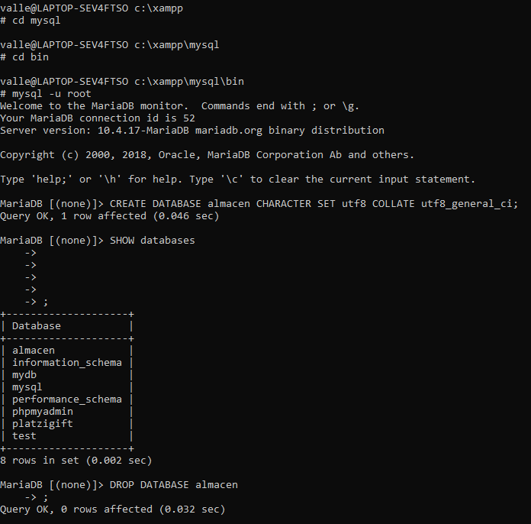

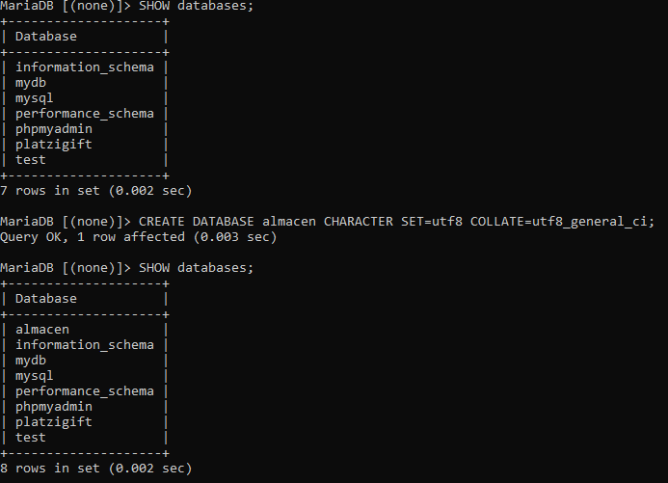

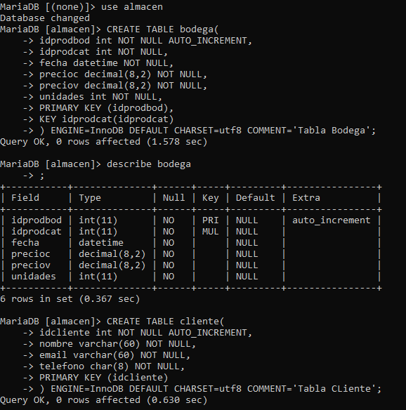

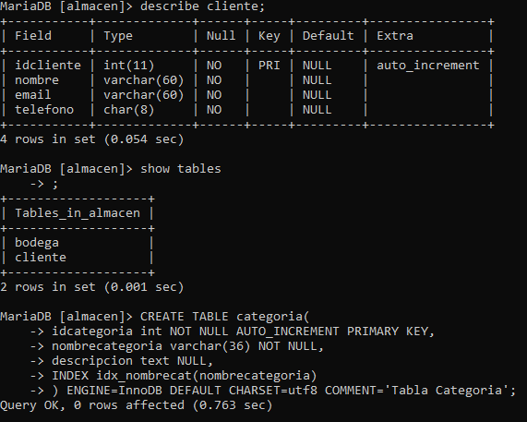

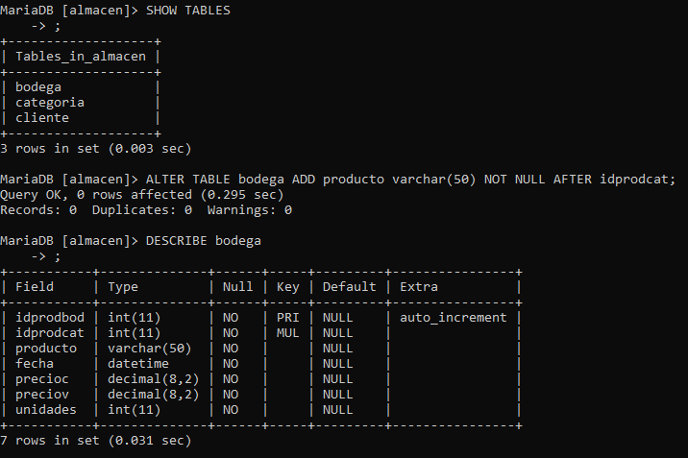

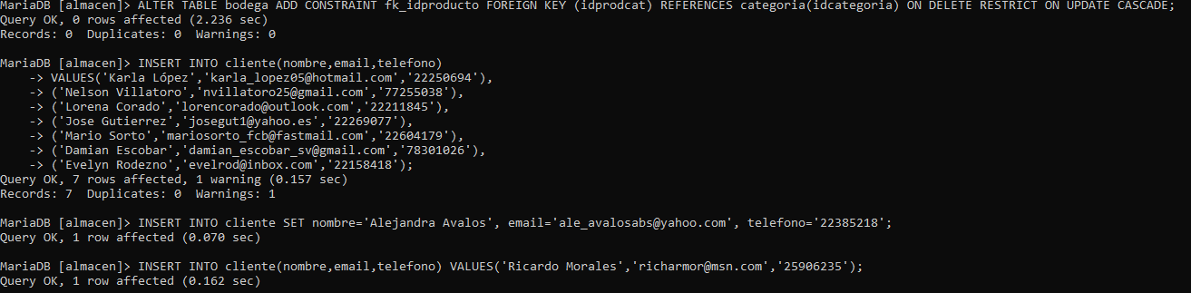

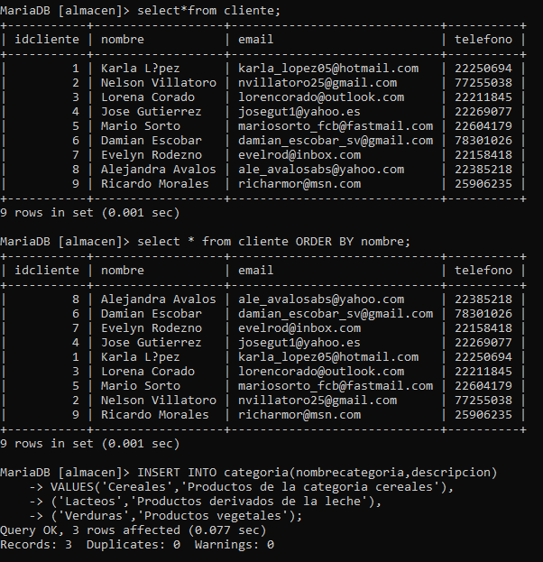

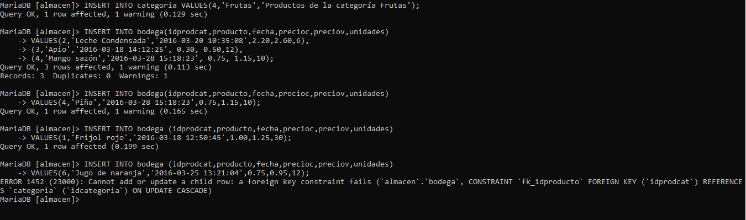

No se pueden Agregar o modificar a ese índice por un fallo con la tabla foránea, pues al buscar un vínculo, este no existe



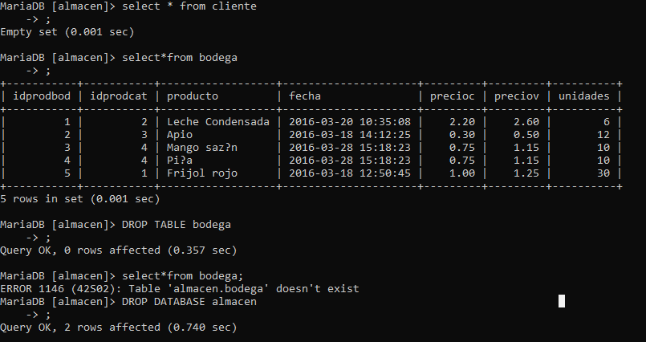

EJERCICIO 3

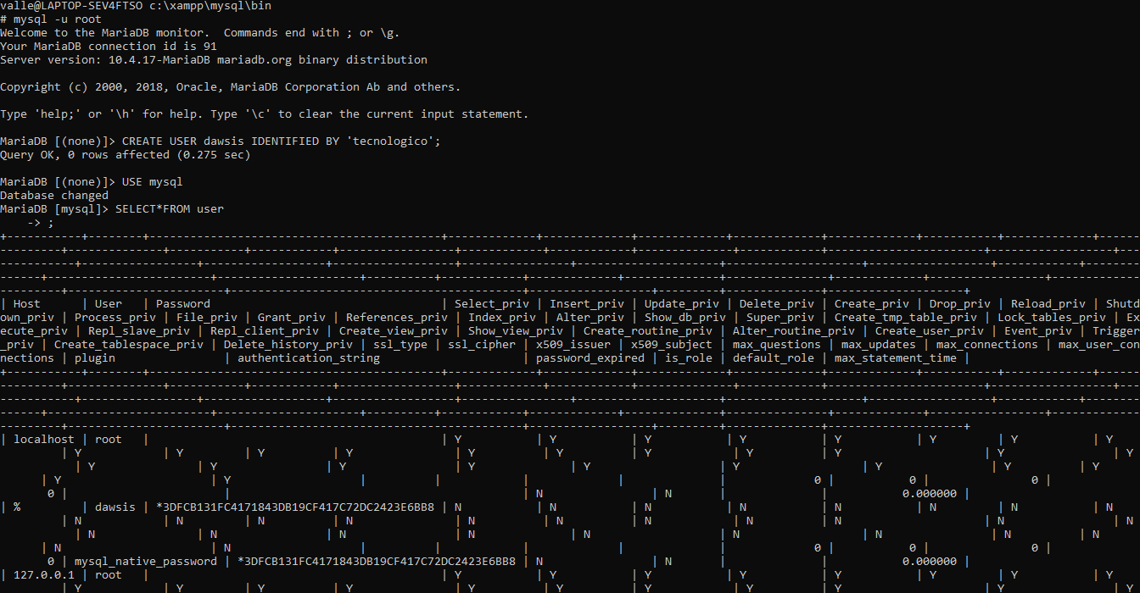

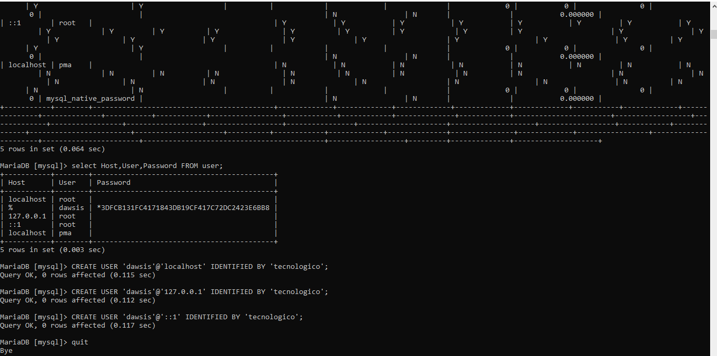

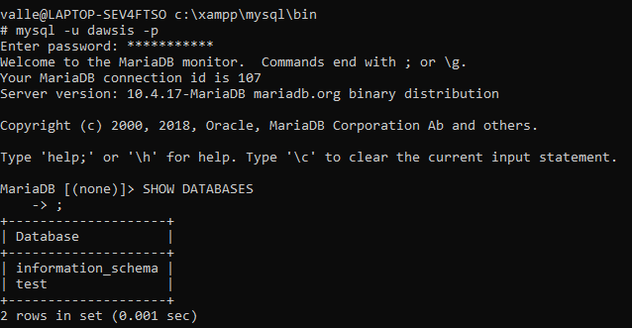

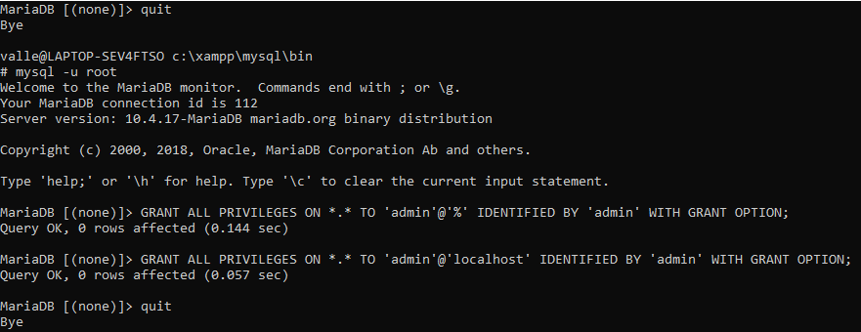

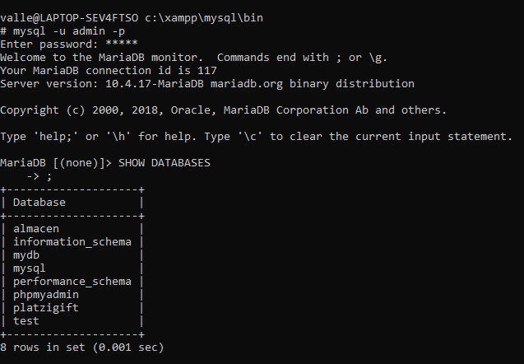

EJERCICIO 4

